**Error Propagation**

$Z = P±Q±R±…{ S}_{Z}^{2}= S_{P}^{2}+S_{Q}^{2}+S_{R}^{2}+…$ ⟹ $S_{Z}= \sqrt{S_{P}^{2}+S_{Q}^{2}+S_{R}^{2}+…}$

$Z ={ P}^{α}∙{ Q}^{β}∙{ R}^{γ} ∙… {\left(\frac{S_{Z}}{Z}\right)}^{2}={\left(α\frac{S_{P}}{P}\right)}^{2}{+ \left(β\frac{S_{Q}}{Q}\right)}^{2}+ {\left(γ\frac{S_{R}}{R}\right)}^{2}+ …$ ⟹ $S_{Z}=\left|Z\right|\sqrt{{\left(α\frac{S_{P}}{P}\right)}^{2}{+ \left(β\frac{S_{Q}}{Q}\right)}^{2}+ {\left(γ\frac{S_{R}}{R}\right)}^{2}+ …}$

$Z ={ κ∙P}^{α}$ ( $κ$ constant) ( $\left|α\right|>0$) ${\left(\frac{S_{Z}}{Z}\right)}^{2}={\left(α\frac{S_{P}}{P}\right)}^{2}$ ⟹ $S_{Z}=\left|Z·α\frac{S_{P}}{P}\right|= \left| κ∙α·{ P}^{α-1}{·S}_{P}\right|$

**Kinematic Equations Percent Diff $\%Diff=\left|\frac{V_{exp}-V_{accepted}}{V_{accepted}}\right|*100\%$**

$$x=vt+ x_{0}$$

$y=\left(\frac{g}{2}\right)t^{2}+ v_{0}t+ y_{0}$**Precision Vs Accuracy Test $\left|V_{exp}-V_{accepted}\right| ? S_{V_{exp}}$**

$$\frac{y}{t}=\left(\frac{g}{2}\right)t+ v_{0}$$

**Equation Applications:**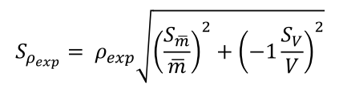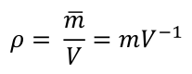

$V=(Area*height)$ $S_{v}=\left|Volume\right|*\sqrt{{\left(\frac{S_{area}}{Area}\right)}^{2}+{\left(\frac{S_{height}}{Heigth}\right)}^{2}}$

For the metal ring that used in the lab, volume and standard deviation are

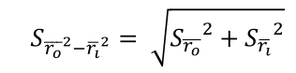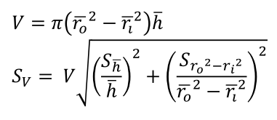





For the TEST object the standard deviation is

$$S_{v}=\left|V\right|*\sqrt{{\left(\frac{\sqrt{\left(2*w*S_{w}\right)+(2πr*S_{r})}}{(w^{2}-πr^{2})}\right)}^{2}{+ \left(\frac{S_{h}}{h}\right)}^{2}}$$